### A Pretty Cupid Pop-Up Card with an Envelope for Valentine's Day

A pop-up card for Valentine's Day. This card and envelope can be cut out of a standard 8 1/2 x 11 paper.

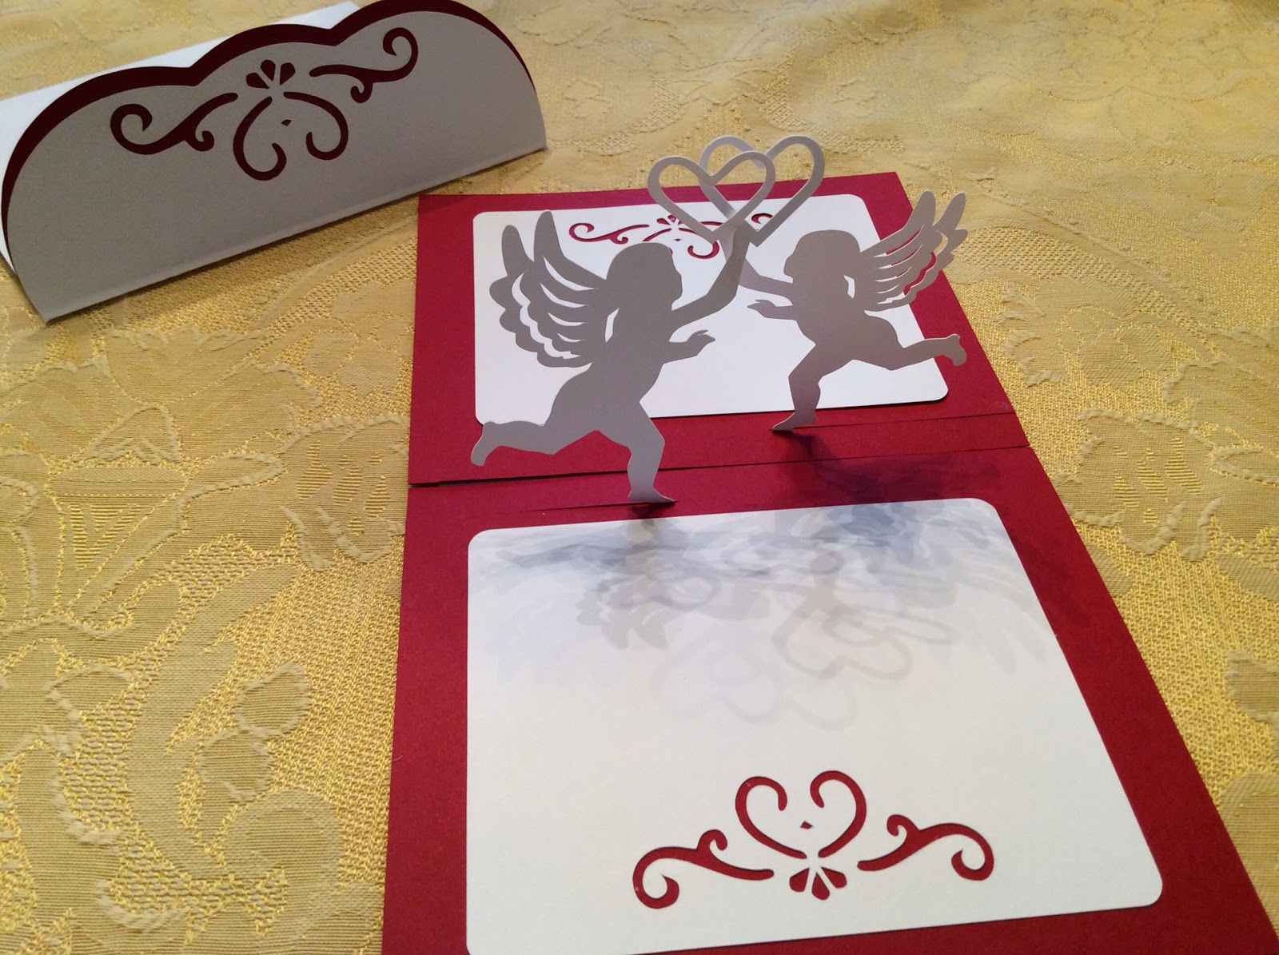

A Cupid with an Entwined Heart Pop-Up Card

Before cutting the file, remove the center line in the piece where there are two cupids. The piece will then need to be folded in half to create the center crease.

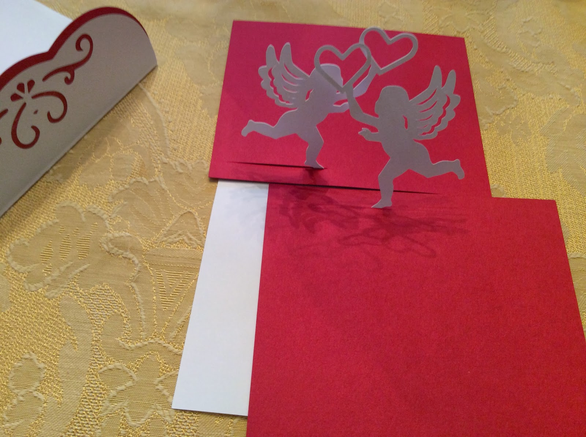

Bend the cupids upward and slide the contrasting color to the inside of the card. Before gluing, test the placement of the contrasting paper so that the slit goes in the correct direction. I recommend using a glue stick because it does not warp the paper.

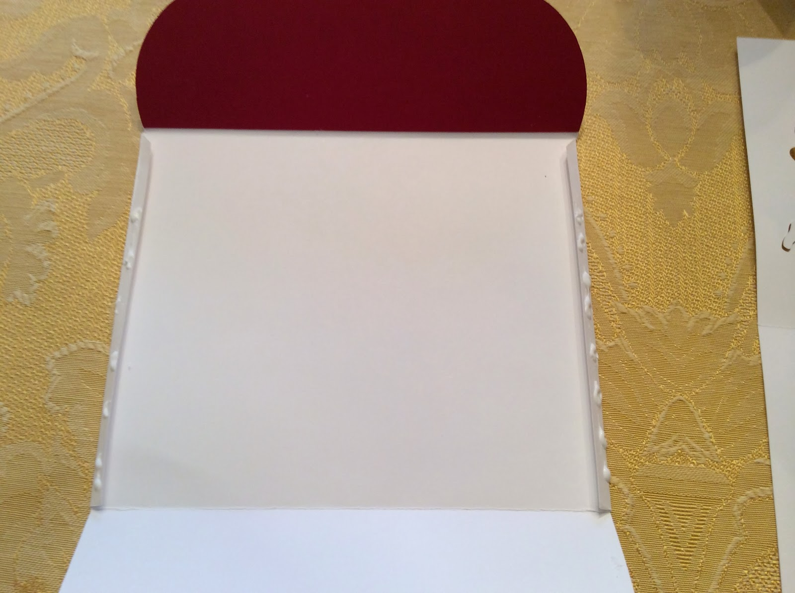

There are no fold lines on the envelope. Fold over the sides about 1/4 inch and glue as shown. Add the contrasting paper to the flap of the envelope by offsetting the paper a little bit so that the color shows on the sides of the flap.

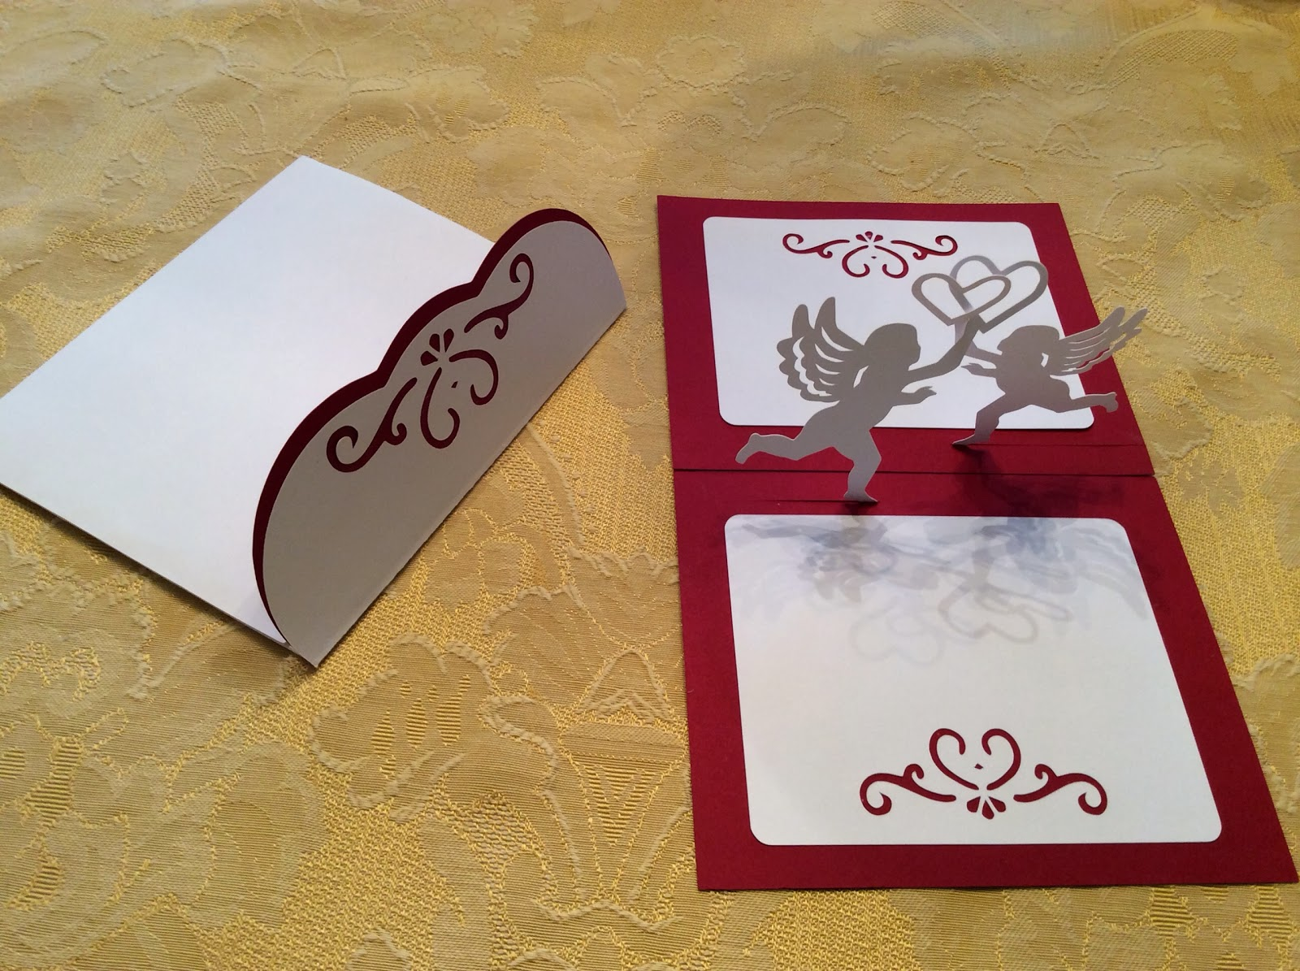

Glue the white paper to the card.

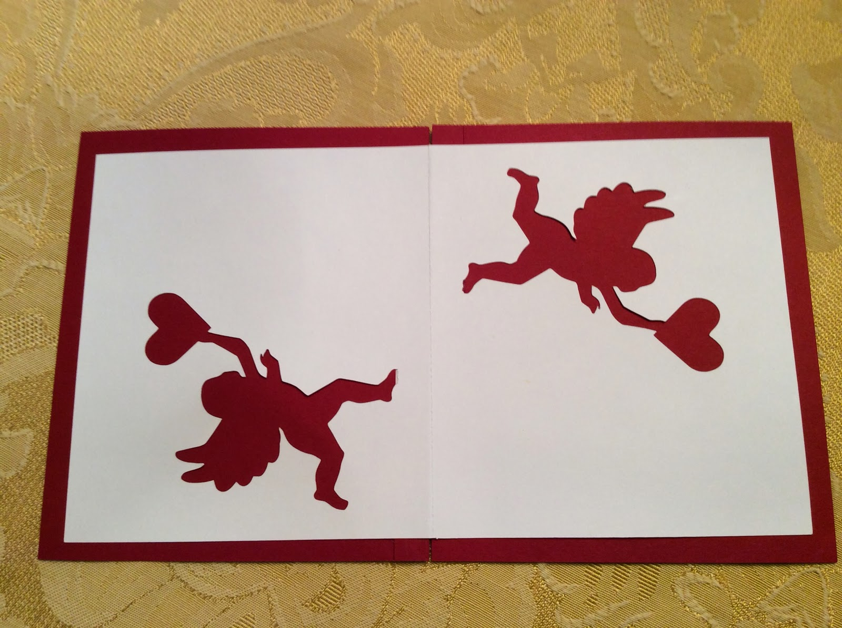

The outside face of the card.

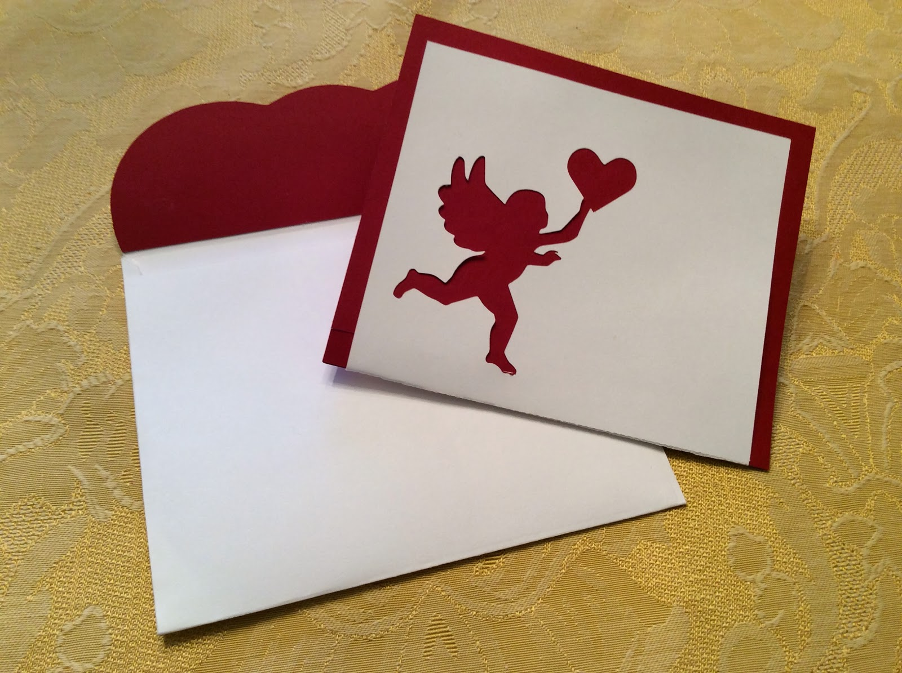

The card looks gorgeous when folded!

Happy Valentine's Day!